

**SMART PARKING SYSTEM**

**A PROJECT BASED LEARNING REPORT**

*Submitted by*

**NITHISH KUMAR . C (21EC055)**

**PRADEEP .C (21EC057)**

**RANJITH .M (21EC064)**

**VISHNUPRIYA .Y (21EC103)**

**VIKRAM .P (21ECL26)**

*In partial fulfilment for the award of the degree*

*of*

**BACHELOR OF ENGINEERING**

**IN**

**ELECTRONICS AND COMMUNICATION ENGINEERING**

**NANDHA ENGINEERING COLLEGE, ERODE**

**(AUTONOMOUS)**

**(Affiliated to Anna University, Chennai)**

**APRIL 2024**

**NANDHA ENGINEERING COLLEGE, ERODE**

**(AUTONOMOUS)**

**(Affiliated to Anna University, Chennai)**

**BONAFIDE CERTIFICATE**

Certificate that this project report “**SMART PARKING SYSTEM”** is the bonafide work of **“NITHISHKUMAR.C, PRADEEP.C, RANJITH.M, VISHNUPRIYA.Y, VIKRAM.P”** who carried out the Project Based Learning work under my supervision.

**SIGNATURE,**

**Mr.G.Rathanasabhapathy,M.E,(Ph.D)**

Assistant Professor/ECE

PBL COORDINATOR,

Department of ECE,

Nandha Engineering College,

(Autonomous)

Erode-638052.

**ACKNOWLEDGEMENT**

The success of a work depends on the team work and co-operation various involved either directly or indirectly.

We express our thanks to our beloved Chairman of Nandha Institutions **Thiru.V.Shanmugam** for providing us all the basic amenities to complete the course successfully.

We wish to convey our earnest gratefulness to our cherished Secretary **Thiru.S.Thirumoorthi** for the excellent facilities provided to the project work successfully.

We wish to express our deep sense of gratitude and thanks to our beloved Principal **Dr.U.S.Ragupathy** for the encouragement and support during the course study.

We wish to express our deep sense of gratitude and thanks to our beloved Principal **Dr. U.S. Ragupathy** for the excellent facilities provided during the course study and project work.

We wish to express our hearty thanks to Dean **Dr. S. Kavitha,** Department of Electronics and Communication Engineering for providing continuous support during the project work.

We are highly indebted to our project guide **Mr.G.Rathanasabhapathy.** Assistant Professor, Department of ECE, for his guidance and motivation in completing the project.

We thank all the Teaching and Non-Teaching staff members of Electronics and Communication Engineering Department for their support to our project work. We also express our thanks to our family members and friends for their encouragement, timely help and suggestion.

**TITLE OF CONTENT**

|  |  |  |  |  |  |
| --- | --- | --- | --- | --- | --- |
| **SI. NO** | **TITLE** |  | |  | **PAGE NO** |
| **1**  **2** | ABSTRACT  INTRODUCTION |  | |  | **6** |
| 3  4  5  6  7  8  9  10  11 | OBJECTIVE  BLOCK DIAGRAM  WORKING AND ITS PRINCIPLE  CIRCUIT DIAGRAM  COMPONENTS AND ITS DESCRIPTION  ADVANTAGES AND APPLICATIONS  RESULT  CONCLUSION  REFERENCE | |  |  | **8**  9  11  12  13  15  16  17  18  19 |

**ABSTRACT:**

Car parking is a major issue in modern congested cities of today. There simply are too many vehicles on the road and not enough parking spaces. We led to the need for efficient parking management systems. This we demonstrate the use of IOT based parking management system that allows for efficient parking space utilization using IOT technology. To demonstrate the concept, we use IR sensors for sensing parking slot occupancy along with a dc motor to simulate as gate opener motors. We now use a Wi-Fi modem for internet connectivity and a microcontroller for operating the system. We create a webpage for online connectivity and IOT management GUI design. The system detects the parking slots are occupied using IR sensors. The system reads the number of parking slots available or occupied and updates data with the cloud server to allow for checking parking slot availability online. This allows users to check for available parking spaces online from anywhere and available hassle-free parking. Thus, the system solves the parking users an efficient IOT based parking management system. In recent research in metropolitan cities the parking management problem can be viewed from various angles such as high vehicle density on roads. This results in annoying issues for the drivers to park their vehicles as it is very difficult to find a parking slot. The drivers usually waste time and effort in finding parking space and end up parking their vehicles finding a space on the street which further leads to space congestion. In worst case, people fail to find any parking space especially during peak hours and festive season.

**CHAPTER 1**

**INTRODUCTION**

The project entitled smart parking system is to manage all the parking facilities to an user. The recent growth in economy and due to the availability of low-price cars in the market, an every average middle-class individual can afford a car, which is good thing, however the consequences of heavy traffic jams, pollution, less availability of roads and spot to drive the motor car. One of the important concerns, which is to be taken in accounting, is the problem of parking those vehicles. Though, if there is space for parking the vehicle but so much time is squandered in finding that exact parking slot resulting in more fuel intake and not also environment friendly. It will be a great deal if in some way we find out that the parking itself can provide the precise vacant position of a parking slot then it'll be helpful not limited to the drivers also for the environment. Initially when the user is about to enter the location the LCD displays the number of empty and filled spots and when the user is with its vehicle near to the parking detect sensor, he/she would be thrown with a notification on their mobile app of the parking slot number, where they should park there vehicle.

### **1.1 Hardware required:**

The hardware requirements are

* ESP Wroom-32
* IR Sensor
* Servo motor
* LCD display

### **CHAPTER 2**

### **OBJECTIVE**

Smart Parking involves the use of low-cost sensors, real-time data and applications that allow users to monitor available and unavailable parking spots. The goal is to automate and decrease time spent manually searching for the optimal parking floor, spot and even lot. Some solutions will encompass a complete suite of services such as online payments, parking time notifications and even car searching functionalities for very large lots. A parking solution can greatly benefit both the user and the lot owner.

Optimized parking – Users find the best spot available, saving time, resources and effort. The parking lot fills up efficiently and space can be utilized properly by commercial and corporate entities.

Reduced traffic – Traffic flow increases as fewer cars are required to drive around in search Increased Safety – Parking lot employees and security guards contain real-time lot data that can help prevent parking violations and suspicious activity. License plate recognition cameras can gather pertinent footage. Also, decreased spot-searching traffic on the streets can reduce accidents caused by the distraction of searching for parking. of an open parking space. Reduced pollution – Searching for parking burns around one million barrels of oil a day. An optimal parking solution will significantly decrease driving time, thus lowering the amount of daily vehicle emissions and ultimately reducing the global environmental footprint.

Decreased Management Costs – More automation and less manual activity saves on labour cost and resource exhaustion.

Enhanced User Experience – A smart parking solution will integrate the entire user experience into a unified action. Driver’s payment, spot identification, location search and time notifications all seamlessly become part of the destination arrival process.

### **CHAPTER 3**

### **BLOCK DIAGRAM**

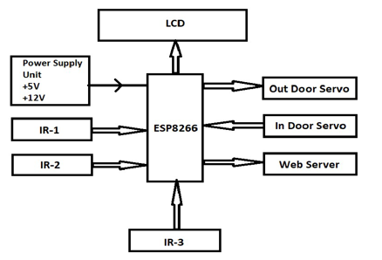

**Figure 3.1 Block diagram**

In this project we are using NodeMCU, IR sensors, and servo motors. One IR sensor is used at entry and exit gate to detect the car while two IR sensors are used to detect the parking slot availability. Servo motors are used to open and close the gates according to the sensor value. NodeMCU is an open source IoT platform. It includes firmware which runs on the ESP8266 WiFi SoC from Espressif Systems, and hardware, which is based on the ESP-12 module. The term “NodeMCU” by default refers to the firmware rather than the dev kits. The firmware uses the Lua scripting language. The ESP8266 is a low-cost Wi-Fi enabled microchip with full TCP/IP stack and microcontroller capability. NodeMCU includes CPU core, faster Wi-Fi, more GPIOs, and supports Bluetooth 4.2, and low power Bluetooth. The ESP8266 is a low-cost Wi- Fi enabled microchip with full TCP/IP stack and microcontroller capability. NodeMCU includes CPU core, faster Wi-Fi, more GPIOs, and supports Bluetooth 4.2, and low power Bluetooth. As soon as the IR sensors get the presence of a car in front of the entrance, it will send signal to the NodeMCU to check if there is an empty slot inside the parking lot. When NodeMCU acknowledges that there is an empty slot or more then it will send a signal to the dc servo motor which will open the main entrance. On the other hand, if an NodeMCU encounters no empty slots at the time of a car trying to make an entrance, the gate will just not open. In addition, there will be a website linked with the NodeMCU board to show the number of parking.

**CHAPTER 4**

### **CIRCUIT DIAGRAM**

### 

**Figure 4.1. Circuit diagram**

The below diagram shows the pin diagram of our model. It consists of one NODE MCU one dc motor, one 16*2 LCD display and three IR sensors. The node mcu is the brain of our system which powers all the other devices. The 16*2 LCD display is powered by node mcu by connecting jumper wires from the display to NODE MCU. The DC motor is also powered by node mcu with connecting its pins to node mcu. The IR sensor consists of three pins, where two pins refer to the power supply and ground and the other pins refer to the pin which is going to be connected in the NODE MCU. On successfully connecting all the components in the given figure now we have to connect the blink app. While using the blink app we have to specify the widgets used in our android app and the pin number to which they are connected to node Mcu in the actual model so that the mobile app will react exactly to the inputs provided in the model.

**CHAPTER 5**

**COMPONENTS AND ITS DESCRIPTION**

**5.1 NODEMCU**

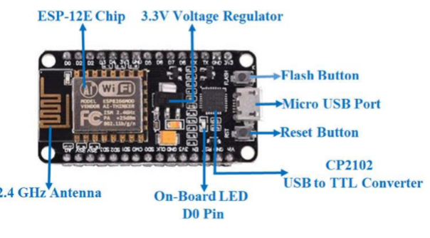

**Figure 5.1 nodemcu**

NodeMCU is an open-source Lua based firmware and development board specially targeted for IoT based Applications. It includes firmware that runs on the ESP8266 Wi-Fi SoC from Espressif Systems, and hardware which is based on the ESP-12 module. NodeMCU Specification & Features Microcontroller: Tensilica 32-bit RISC CPU Xtensa LX106 Operating Voltage: 3.3V Input Voltage: 7-12V Digital I/O Pins (DIO): 16 Analog Input Pins (ADC): 1 UARTs: 1 SPIs: 1 I2Cs: 1 Flash Memory: 4 MB SRAM: 64 KB Clock Speed: 80 MHz USB-TTL based on CP2102 is included onboard, Enabling Plug n Play PCB Antenna Small Sized module to fit smartly inside your IoT projects

The NodeMCU ESP8266 development board comes with the ESP-12E module containing the ESP8266 chip having Tensilica Xtensa 32-bit LX106 RISC microprocessor. This microprocessor supports RTOS and operates at 80MHz to 160 MHz adjustable clock frequency. NodeMCU has 128 KB RAM and 4MB of Flash memory to store data and programs. Its high processing power with inbuilt Wi-Fi / Bluetooth and Deep Sleep Operating features make it ideal for IoT projects.

NodeMCU can be powered using a Micro USB jack and VIN pin (External Supply Pin). It supports UART, SPI, and I2C interface.

Applications Prototyping of IoT devices Low power battery operated applications Networking Projects Projects requiring multiple I/O interfaces with Wi-Fi and Bluetooth functionalities.

**5.2 IR SENSORS**

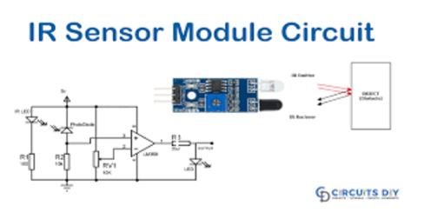

**Figure 5.2 IR sensor**

An infrared (IR) sensor is an electronic device that measures and detects infrared radiation in its surrounding environment. Infrared radiation was accidentally discovered by an astronomer named William Herchel in 1800. While measuring the temperature of each colour of light (separated by a prism), he noticed that the temperature just beyond the red light was highest. IR is invisible to the human eye, as its wavelength is longer than that of visible light (though it is still on the same electromagnetic spectrum). Anything that emits heat (everything that has a temperature above around five degrees Kelvin) gives off infrared radiation. We are using three IR detect sensor in our project, one IR detect sensor is used to sense the vehicle near the parking sensor and other two IR detect sensor is used to send data to the Node MCU which is the brain of our system whether a vehicle is parked in that slot or is unparked

There are two types of infrared sensors: active and passive. Active infrared sensors both emit and detect infrared radiation. Active IR sensors have two parts: a light emitting diode (LED) and a receiver. When an object comes close to the sensor, the infrared light from the LED reflects off of the object and is detected by the receiver. Active IR sensors act as proximity sensors, and they are commonly used in obstacle detection systems (such as in robots).

Active output level: Outputs low logic level when obstacle is detected. On board obstacles detection LED indicator Ultrasonic sensor is used in this parking system The range of the IR sensor is between 1-2 meters/3-15 feet.

**5.3 LCD DISPLAY**

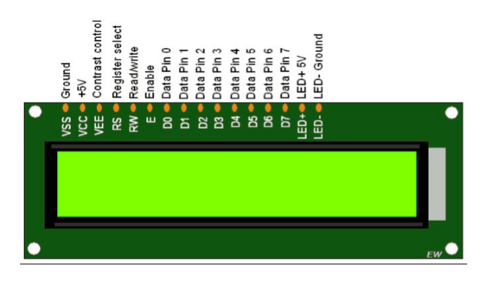

**Figure 5.3 LCD display**

An LCD is an electronic display module which uses liquid crystal to produce a visible image. The 16×2 LCD display is a very basic module commonly used in DIY’s and circuits. The 16×2 translates to an the display 16 characters per line in 2 such lines. In this LCD each character is displayed in a 5×7-pixel matrix. The 16*2 display is used to display the number of vacant and spilled spot. It also gets updated on the display LCD when a vehicle parks or unparks the vehicle.

TYPES OF LCDs Twisted Nematic (TN)- which are inexpensive while having high response times. However, TN displays have low contrast ratios, viewing angles and colour contrasts.

In Panel Switching displays (IPS Panels)- which boast much better contrast ratios, viewing angles and colour contrast when compared to TN LCDs.

Vertical Alignment Panels (VA Panels)- which are seen as a medium quality between TN and IPS displays.

Advanced Fringe Field Switching (AFFS)- which is a top performer compared IPS displays in colour reproduction range.

**5.4 SERVO MOTORS**

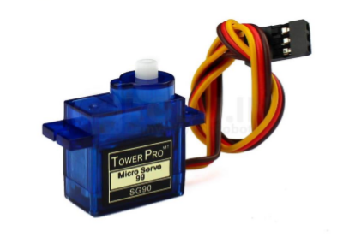

**Figure 5.4 Servo motor**

A servomotor (or servo motor) is a rotary actuator or linear actuator that allows for precise control of angular or linear position, velocity and acceleration. It consists of a suitable motor coupled to a sensor for position feedback. In this project we use servo motors to open the gate of the parking slot when the vehicle is detected at the entrance. When the car is leaving the parking slots the servo motors helps to lift the gate and helps the car to leave the parking slots.

**5.3 Working:**

ESP32-CAM placed on daughter board and it is having 5V power supply and all digital pin outs. We can easily mounted ESP32-CAM on this daughter board for easy connectivity. Relay Connected to ESP32-CAM digital pin and it can control solenoid valve. Also toggle button connected to ESP32-CAM digital pin. This digital pin helps us to send request notification to telegram app. After pressing this button we will get notification on telegram app along with photo. Then we can unlock door from app. Green LED will be ON while accessing ESP32-CAM with telegram app. This smart door lock is very effective and communication is very fast than any other cloud based IOT apps or web systems.

**CHAPTER 6**

**ADVANTAGES AND APPLICATIONS**

* Optimized parking
* Reduced Traffic
* Reduced Pollution
* Enhanced User Experience
* Integrated Payments and POS Increased Safety
* Decreased Management Cost Shorter waiting time at the parking place
* Carbon Emission is reduced

**Applications**

The smart parking system can be implemented in

* Shopping Malls
* Restaurants
* Theatres

**CHAPTER 7**

**RESULT**

**Stage 1:**

When the car enters the parking area the IR sensor that is present before IN gate will detect the passing vehicle and the gate will be opened automatically.

**Stage 2:**

The car will enter into the parking area at the time person doesn’t know which slot is empty, for this there will be an indication of LEDs for every slot when the Green Light glows the slot is empty when the red light glows the slot was filled. By the person easily know which slot is empty.

**Stage 3:**

The operation of exit will be same as that of the entrance. When the car leaves the parking area, The IR sensor thar is present before the OUT gate will detect the passing vehicle and the gate will be opened automatically.

**Stage 4:**

In front of the parking area, there will be an LCD display that is used to show the status of the parking slots, whether the parking is available or not.

**CHAPTER 8**

**CONCLUSION**

The concept of Smart Cities has always been a dream for humanity. Since the past couple of years ago large advancements have been made in making smart cities a reality.

The growth of Internet of Things and Cloud technologies have given rise to new possibilities in terms of smart cities. Smart parking facilities and traffic management systems have always been at the core of constructing smart cities. In this project, we address the issue of parking and present an IoT based Cloud integrat

ed smart parking system. The system that we propose provides real time information regarding availability of parking slots in a parking area. Users from remote locations could book a parking slot for them by the use of our mobile application. The efforts made in this project are intended to improve the parking facilities of a city and thereby aiming to enhance the quality of life of its people.

**CHAPTER 9**

**SOURCE CODE**

#include <Wire.h> // Include the Wire library

#include <LiquidCrystal_I2C.h> // Include the LiquidCrystal_I2C library

#define I2C_ADDRESS 0x27 // I2C address of the LCD module

#define LCD_COLUMNS 16 // Number of columns in the LCD

#define LCD_ROWS 4 // Number of rows in the LCD

LiquidCrystal_I2C lcd(I2C_ADDRESS, LCD_COLUMNS, LCD_ROWS); // Create a new LiquidCrystal_I2C object

bool s1 = false;

bool s2 = false;

bool s3 = false;

bool s4 = false;

char s5[] = "Parking Empty";

#define ir_car1 33

#define ir_car2 25

#define ir_car3 32

#define ir_car4 35

int S1 = 0, S2 = 0, S3 = 0, S4 = 0;

int slot = 4; // Total number of parking slots

// Function declaration

void Read_Sensor();

void setup() {

// Initialize serial and wait for port to open:

Serial.begin(9600);

// This delay gives the chance to wait for a Serial Monitor without blocking if none is found

delay(1500);

// Initialize the I2C communication

Wire.begin(21, 22);

// Initialize the LCD screen

lcd.begin(); // no arguments needed for initialization

// Turn on the backlight of the LCD screen

lcd.backlight();

pinMode(ir_car1, INPUT);

pinMode(ir_car2, INPUT);

pinMode(ir_car3, INPUT);

pinMode(ir_car4, INPUT);

lcd.setCursor(0, 1);

lcd.print(" Car parking ");

lcd.setCursor(0, 2);

lcd.print(" System ");

delay(2000);

lcd.clear();

// Call the function to read sensors

Read_Sensor();

}

void loop() {

Read_Sensor();

// Update available slots dynamically

int total = S1 + S2 +S3 +S4;

slot = 4 - total;

lcd.setCursor(0, 0);

lcd.print(" Have Slot: ");

lcd.print(slot);

lcd.print(" ");

lcd.setCursor(0, 1);

if (S1 == 1) {

s1 = true;

lcd.print("S1:Fill ");

} else {

s1 = false;

lcd.print("S1:Empty");

}

lcd.setCursor(10, 1);

if (S2 == 1) {

s2 = true;

lcd.print("S2:Fill ");

} else {

s2 = false;

lcd.print("S2:Empty");

}

lcd.setCursor(0, 2);

if (S3 == 1) {

s3 = true;

lcd.print("S3:Fill ");

} else {

s3 = false;

lcd.print("S3:Empty");

}

lcd.setCursor(10, 2);

if (S4 == 1) {

s1 = true;

lcd.print("S4:Fill ");

} else {

s4 = false;

lcd.print("S4:Empty");

}

if (s1 && s2 && s3 && s4) {

strcpy(s5, "Parking is Full");

} else {

strcpy(s5, "Parking Empty");

}

lcd.setCursor(0, 3);

lcd.print(s5);

delay(1000); // Adjust delay as needed

}

void Read_Sensor() {

S1 = 0, S2 = 0, S3 = 0, S4 = 0;

if (digitalRead(ir_car1) == 1) {

S1 = 1;

}

if (digitalRead(ir_car2) == 1) {

S2 = 1;

}

if (digitalRead(ir_car3) == 1) {

S3 = 1;

}

if (digitalRead(ir_car4) == 1) {

S4 = 1;

}

}

**CHAPTER 11**

**REFERENCE**

[1] Abdul Ahad, Zishan Raza Khan, Syed Aqeel Ahmad, “Intelligent Parking System” Scientific Research Publishing, Vol.4, No.2, pp. 160-167, May 2016.

[2] Dr Y Raghavender Rao,” Automatic Smart Parking System using Internet of Things (IOT)” International Journal of Engineering Technology Science and Research, Vol.4, No.5, pp.225-258, May 2017

[3] Suprit Atul Gandhi, Hasan Mohammad Shahid,” Smart Parking System”

[4] Asian Journal of Convergence in Technology, Vol.4, No.1, May 2017Benson, J.P., T. O'Donovan, P. O'Sullivan, U. Roedig and C. Sreenan et al.,” Car park management using wireless sensor networks”, Proceedings of the 31st Conference on Local Computer Networks, Tampa, FL., USA., pp: 588-595 November 2006.

[5] Geng Y. and Cassandras C. G, “A new smart parking system based on optimal resource allocation and reservations,” in Proc. IEEE Conf. Intell. Transp. Syst. pp. 979– 984, July 2011.

[6] M. M. Rashid, A. Musa, M. Ataur Rahman, and N. Farahana, A. Farhana, “Automatic Parking Management System and Parking Fee Collection Based on Number Plate Recognition.”, International Journal of Machine Learning and Computing, Vol. 2, No. 2, April 2012, Published 2014.

[7] Arduino.cc. (2018). Arduino - ArduinoMega2560. , retrieved date: 21Oct.2018, online available at:https://www.arduino.cc/en/Guide/ArduinoMega2560